Chapter 11 Review Questions
- A drop-down menu on a window can provide _________ operations.
- The ___________ method closes a window and ends the program.
- An asterisk with an import statement is referred to as a _______________.
- The __________ method is used to center a window in the display area.
- The ___________ function can be used to prevent a window from being resized.
- The _______ file format is used with the iconbitmap() method to change the window icon.
- When a StringVar is assigned to a component, any change to the StringVar value immediately _________ the component.
- When plotting on a canvas, the 0, 0 coordinates are located at the _________ of the canvas.
- A _______ expression is an inline function with no name.

Chapter 11 Short Answer Exercises
- What function is assigned to the “Exit” menu item in the following statement?
self.file_menu.add_command(label=”Exit”, command=self.main_win.destroy( ))
- Where will the following statement place the window when it is created?
self.main_win.geometry(‘300x300+100+200’)
- What is the size of the window in the following statement?
self.main_win.geometry(‘300x300+100+200’)
- Where will the following statement place the window when it is created?
x_crd = int((self.main_win.winfo_screenwidth() – 300)/2)
x_crd = int((self.main_win.winfo_screenheight() – 300)/2)
self.main_win.geometry(‘%dx%d+%d+%d’, %(300,300,x_crd,y_crd’)
- What does the following statement accomplish?
self.main_win.resizable(False, False)
- In the following expression, how much character space is allocated in the formatting?
value_string = ‘{:>10}’.format(value)
- In the following expression, what is the effect of the greater than character?
value_string = ‘{:>10}’.format(value)
- In the following expression, why is the word lambda included?
tk.Button(text=’Click’, command = lambda : print(‘Click’))
- What window is the “owner” of the canvas in the following statement?
self.canvas = tkCanvas(self.plot_win, width=500, height=500)

Chapter 11 Programming Exercises
- Implement a window with the title and menu shown below. When the menu items are clicked, print that an item was clicked.
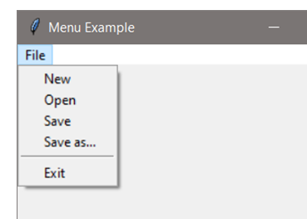

- Implement a 400x400 non-resizable window that is centered in the display area when the program runs.
- Implement a window with an image. The window should be 410x410 and the image 200x200. Center the image in the window.
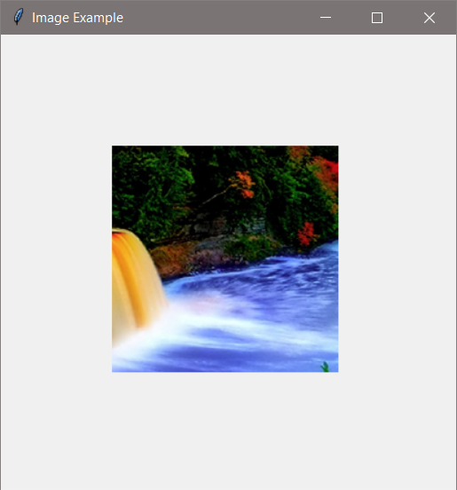

- Implement a program with a window that has a button that updates a label that displays how many times the button was clicked. Use a StringVar in the solution.
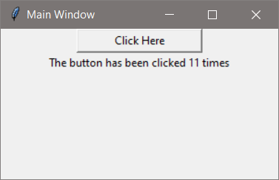
- Implement a window with a button that creates a second window when it is clicked.
- Implement a two window program. The first window will have a button that updates a label on the second window and displays how many times the button was clicked. Use a StringVar in the solution. The second window should be a Toplevel window.

- Implement a window that is 300 x 300 with a canvas, and plot the text below at those coordinates. Make the font for the text Consolas, 12, and bold.
50, 50 250, 50 150,150
50, 250 250, 250

Chapter 11 Programming Challenges
#1 – Two-window Close Both
Design and implement a program with two windows. When either window is closed the other window should be destroyed and the program should end.
#2 – Display and Plot Values
Design and implement a GUI program that allows the user to input a radius and displays a circle with that radius on a canvas in a second window. The circle should be centered in the window.
#3 – Drawing on a Canvas
Implement a 600x600 window with a 400x400 canvas with a background, three (3) radio buttons that select a color, and a “Draw” button. When the button is clicked, draw a rising set of 19 bars in the color selected.
