Chapter 10 Review Questions
- GUIs are _________ driven by _________ input.
- The ___________ module in Python can be used to develop GUI programs.
- The GUI component used to display one line of text is a ___________.
- The GUI component used to obtain a single line of user input from the keyboard is an ___________.
- A function or method that is called when an event occurs is referred to as a ________function.
- The three geometry managers provided by tkinter are: _________, ________, and ________.
- Mutually exclusive means that _________ item in a group can be selected.
- The Grid Geometry Manager can be used to ___________ components in a GUI using rows and columns.
- _______ is the method used to obtain input from an entry component.
- The button option that assigns a callback function is the _________ option.
- The small window used to alert a user to an issue in a GUI application is called a _________________.
- The _________ object and _________ object provide an immediate update to the controls they are assigned to.
- _________ and ___________ are mutually exclusive controls and users can select only one, whereas _________ are not and multiple selections can be made.

Chapter 10 Short Answer Exercises
- Write a statement that creates a label called label1 for self.win with the text “Python is fun!”
- Write a statement that creates an entry control called user_input for self.win that allows for 10 characters of input.
- What does the following statement accomplish/allow?
import tkinter as tk
- In the following compute button creation, what is the text on the button?
self.btn1 = tk.button(text=’Compute’, font=(‘Arial’,14), command = self.compute_value)
- In the following compute button creation, what is the callback function?
self.btn1 = tk.button(text=’Compute’, font=(‘Arial’,14), command = self.compute_value)
- What does the following statement accomplish?
my_string = self.my_entry.get()
- Write a statement for a show message dialog box with the title “Error” and the text “An error has occurred”.
- What does the following statement accomplish?
self.win.columnconfigure(1, minsize=50)
- Where are the coordinates (0, 0) located on a tkinter Canvas?

Chapter 10 Programming Exercises
- Implement a class definition for a MyWin Class that generates the window below which is 300 x 200 with a title “Main Window” and a label that says “This is the Label”. Pack can be used to display the label.
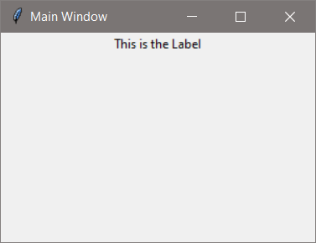
- Using the MyWin Class from #1, add a button to the window with the word “Click Me” on the button. Pack can be used to display the button.
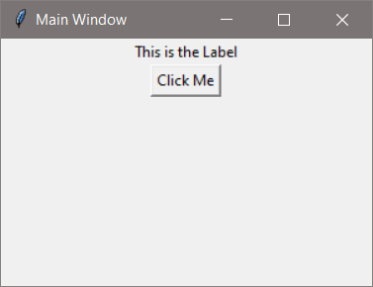

- Create a class InputWin that creates a window and uses the grid geometry manager with six (6) rows configured with a minimum size of 30 pixels and three (3) columns configured with a minimum size of 50 pixels. The window will have a label that prompts the user to input their name into an entry component that is 20 characters wide. The window will have a button (width=18) that obtains the input from the entry component using a command that calls a function that displays “Have a nice day ” and the name that was entered on a second Label. Position the components as follows:
Prompt Label row 1 column 0
Entry row 1 column 1
Output Label row 3 column 0, columnspan=3
Button row 5 column 0, columnspan=3
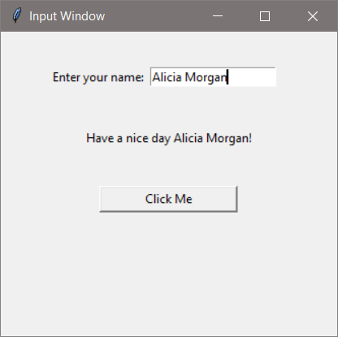
- Modify the InputWin program in #3 to also request the number of tickets to purchase. The button text should be changed to “Purchase”. Change the output label to “Thank you “ and the name entered. If the number of tickets entered is not a positive integer, an error dialog box should appear.
Modify the font for the labels to be “Consolas” 12 and the output label text to blue. The error dialog box text should alert the user to the issue (be sure to import tkinter.messagebox).
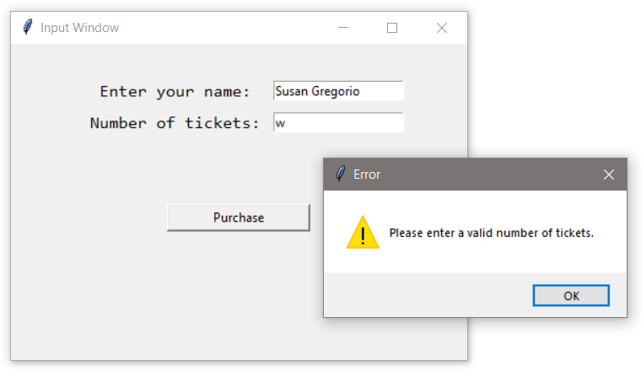

- Modify program #4 to display the Total cost based on a ticket price of $29.50 as shown below. Note the dollar sign and two decimal places in the output.
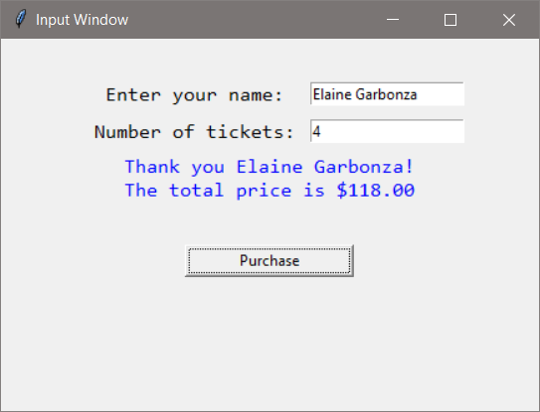

- Implement a Create Account class with a window that obtains a user name and password from the user and validates the password (at least 9 characters, at least one digit, upper, and one lower case letter). If the password is valid, display “An account has been created.” in a dialog box, otherwise use a dialog box to handle the error. The title on the window should be “Create Account”, and the window should display the password requirements to the user.
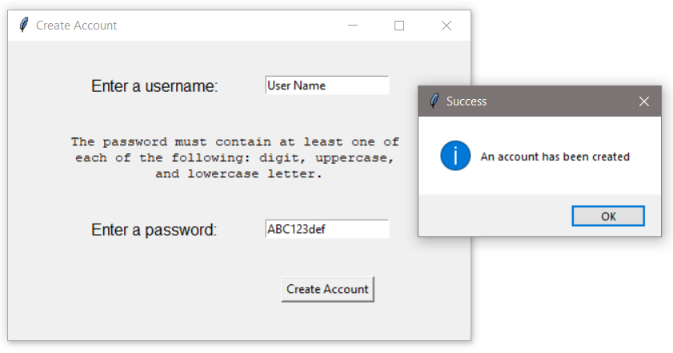

Chapter 10 Programming Challenges
#1 – Theater Ticket GUI with Seat Level Pricing
Design and implement a Class for a Theater GUI that obtains the number of tickets being purchased from the user and allows seat selection: General Admission, Main Floor, and Balcony. The program should use an option list or radio buttons for seat selection, and display an error dialog if the number of seats entered is invalid. Use a label to display the total price based upon the number of tickets sold and the cost for seating as shown below.
General Admission $18.50
Main Floor $37.50
Balcony $26.00
Reminders: the row and column configure values can be assigned individually and as need to accommodate the GUI design. The “sticky” option allows further alignment using “N”, “S”, “E”, and “W”. Radio buttons can use an IntVar or StringVar assignment.
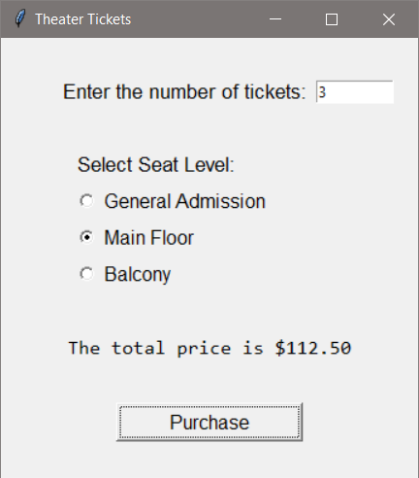

#2 – Pizza Size and Topping GUI
Design and implement a GUI for the Downtown Pizzeria that obtains an order for a pizza by size and topping. The size selection should be done with radio buttons or an option list, and the topping selection with check boxes to accommodate multiple selections. A purchase button will compute the price and display it to the user based upon the prices below.
Medium $12.50
Large $15.50
Anchovies $2.50
X-cheese $3.00
Onions $2.50
Pepperoni $3.50

