Chapter 7 Review Questions
- The characters that follow the name of a file are referred to as the file ______________.
- A file opened for reading is referred to as an _________ file.
- A file opened for writing is referred to as an __________ file.
- In order to use a file in a program, the file must be _________.
- When a file is opened in a program, it is associated with a ____________ that has a variable reference.
- A file opened by a program is opened in a specific _________ such as reading, writing, or appending.
- For file handling, the directory where the program is running is referred to as the __________ directory.
- The _______ method is used to output data to a file.
- An area in memory where data to be written is temporarily stored is referred to as a __________.
- When a program is finished using a file, it should _________ the file.
- The escape sequence or newline character is ________.
- To write a numeric value to a file, it must first be converted to a __________ using the _______ function.
- When a data file is opened for writing using ‘w’, any data existing in the file will be __________.
- Adding to a string or combining two strings is referred to as ___________.
- Adding to the end of a file’s contents is referred to as ______________ to the file.
- When numeric data is read from a file, it must be ______ before using it in an equation.
- A ____________ is a character used to mark the beginning or end of an item of data.
- The ___________ method is used to strip off trailing white space characters.
- The ___________ method is used to parse items of data from a string.
- When an error occurs because a file cannot be found for reading or created for writing, it is referred to as raising an ______________.

Chapter 7 Short Answer Exercises
- Write the statements required to open a file named “test_file.txt” for writing and associate it with the variable reference my_file, write “This is a test.” to the file, and close the file.
- Write the statements required to open a file named “test_file.txt” for writing and associate it with the variable reference my_file, write “This is a test.” to the file, and close the file. Then reopen the file for reading, read a line of text, print the line of text, and close the file.
- Write the statements required to open a file named “numbers.txt”, write the numbers 1, 2, and 3 to the file, and close the file.
- Write the statement to open a file named “numbers.txt” for writing that does not erase the existing data in the file. Associate the file with the name my_file.
- Write the statements required to open a file named “data.txt” for reading in a try block, and the exception handler for an IOError that displays “The file could not be opened”.
- Write the statements required for a try block to read all of the data from a file named “data.txt” and print the contents, and handle an exception.

Chapter 7 Programming Exercises
- Write a program that creates a file for writing called “data.txt” and write the following lines to the file on separate lines and close the file.
The first line
The second line
The third line
The fourth line
The fifth line
The sixth line
- Write a program that creates a file for writing called “data.txt” and write the lines below to the file (or use the file from #1 above) and close the file. Open the file for reading and display the contents of the file.
The first line
The second line
The third line
The fourth line
The fifth line
The sixth line
- Write a program that creates a file for writing called “data.txt” and write the lines below to the file (or use the file from #1 or #2 above) and close the file. Open the file for reading and display the contents of the file with a line number and colon as shown below.
The first line
The second line
The third line
The fourth line
The fifth line
The sixth line
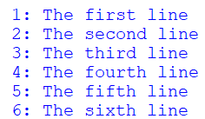
- Write a program that creates a text file named “num_data.txt” and writes the numbers 1001 thru 1020, separated by a tab with four numbers per line.
Data file example:
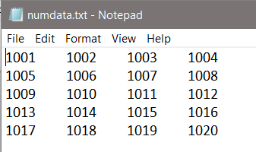

- Write a program that creates a text file named “line_data.txt” and writes the numbers 1001 thru 1020, on separate lines. Then open the file and display the numbers in two columns separated by a tab as shown below. Hint: use strip to remove the line feed.
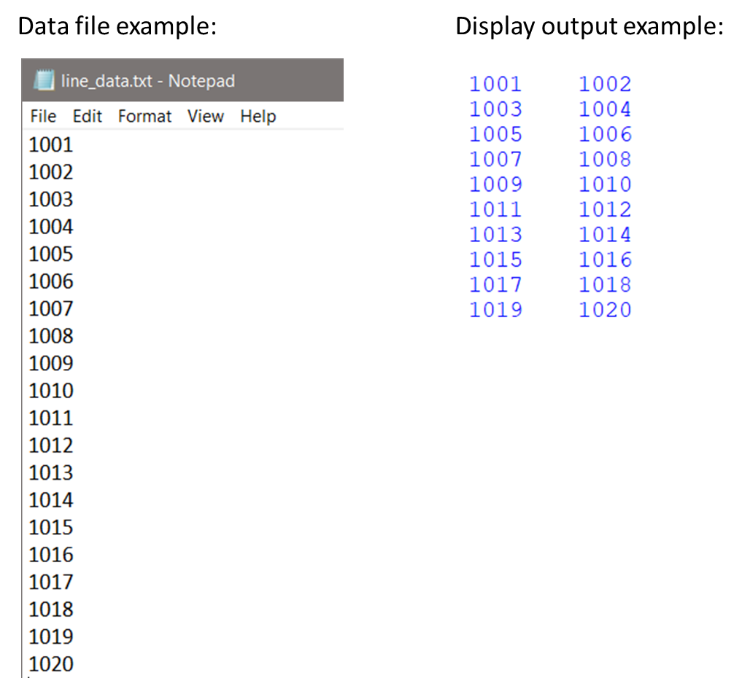

- Create a text file named “sales_data.txt” with the sales data listed below each on a separate line. Write a program that defines main which reads one value from the file at a time and calls a function to compute and return the discount price (20% off), and display the original and discount prices in two (2) columns separated by a tab as shown.
Sales data: 19.64, 3.56, 9.87, 16.33, 12.95, 6.50
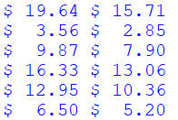

- Create a text file named “products.txt” with the product names and prices listed below them on separate lines. Write a program that reads the data from the file and calls a function to compute and return the discount price for the item (20% off), and display the item name, original price, and sale price in columns with column headers as shown.
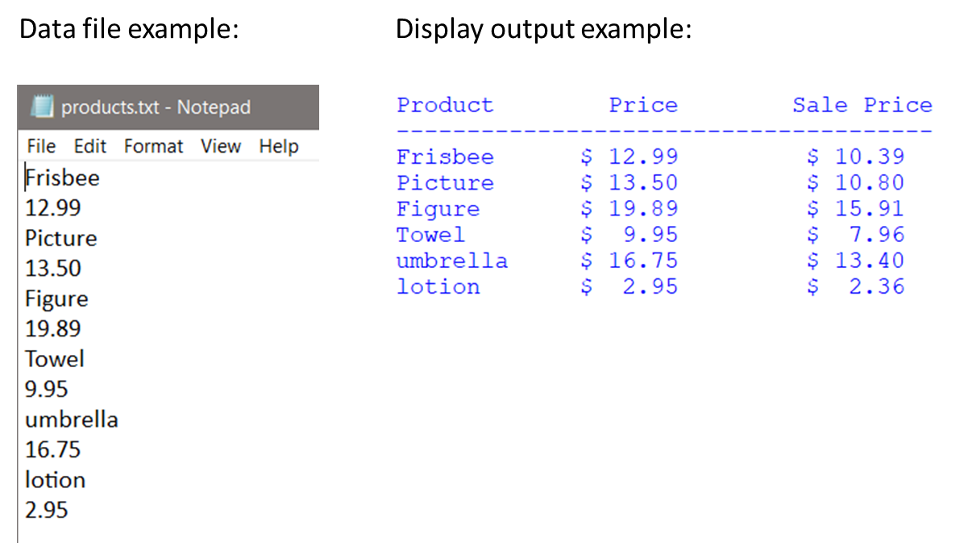

- Create a text file named “some_data.txt” with the following single line in the file.
1.5, 2.5, 3.5, 4.5, 5.5, 6.5, 7.5, 8.5, 9.5, sales
Write a program that opens and reads the file, displays the numbers vertically, totals the numbers, and displays the total. Include a try block and exception handling for an IOError and a ValueError that display appropriate messages. Include a finally clause that closes the file.

Chapter 7 Programming Challenge
Employee Data File
Design and develop a program for a local company payroll that uses the employee data file shown below. The program will read the file and display the name and ID for the employee, and the gross pay for each employee based upon the input file data. The format for the output is shown below. Include two (2) exception handlers in the solution.
The date format for the input file is: name, ID number, hourly rate, and hours worked
