Chapter 5 Review Questions
- A structure that allows repeating steps without repeating code is referred to as a _______________ structure.
- A loop that repeats while some condition is true is a ________ controlled loop.
- Each execution of a loop is referred to as an ____________.
- A while loop is a ___________ loop and may or may not execute depending on the conditional statement.
- A loop that repeats a specific number of times is a _________ controlled loop.
- A loop that continues to run without a control or condition to stop it referred to as an ___________ loop.
- The range function provides a simplified way to write _______ controlled loops.
- When one argument is passed to the range function, it is the ________.
- When two arguments are passed to the range function, the first is the _______ and the second is the _________.
- When three arguments are passed to the range function, the third argument is the ________.
- A variable within a loop that tallies a running total is an _____________.
- A variable within a loop that counts the number of iterations of the loop is referred to as a _____________.
- A value entered by the user that is used by the program to indicate the end of a data set is referred to as a ________.
- A loop within a loop is referred to as a __________ loop.
- Verbalizing and walking through the steps a program will take is known as __________.

Chapter 5 Short Answer Exercises
- What do the following lines of code output if var1 = 6, and var2 = 8?
while var1 < var2:
print(var1, end=’’)
var1 = var1 + 1
- What do the following lines of code output if var1 = 6, and var2 = 8?
while var1 < var2:
print(var1, end=’’)
var1 = var1 + 2
- What do the following lines of code output if var1 = 6, and var2 = 8?
while var1 <= var2:
print(var1)

- What do the following lines of code output if first = 10, and second = 10?
while first < second:
print(‘Enter a number’)
- What do the following lines of code ensure?
value = int (input(“Enter a positive number’)

while value < 1:
value = int (input(“Enter a positive number’)
- What do the following lines of code output?
for counter in range(3):
print(counter, end=’ ‘)
- How many times will following loop display “Hello”?
for counter in range(3, 7):
print(‘Hello’)
- How many times will following loop display “Another”?
for counter in range(2, 10, 2):
print(‘Another’)
- In the following code, what is the variable total?
for counter in range(3):
grade = float(input(‘Enter a grade’)
total = total + grade
- In the following code, what is the variable num?
for counter in range(3):
grade = float(input(‘Enter a grade’)
total = total + grade
num = num + 1
- In the following code, what is 999?
while grade != 999:
grade = float(input(‘Enter a grade or 999 when finished.’)

Chapter 5 Programming Exercises
- Write a program that sets a variable num to 0 and uses a while loop to display the numbers 0 thru 9 separated by a space.
- Write a program that sets a variable num to 0 and uses a while loop to display the even numbers 0 thru 20 separated by a space.
- Write a program with a for-in-range loop that displays the numbers 0 thru 9 separated by a space.
- Write a program with a for-in-range loop that displays the even numbers 0 thru 20 separated by a colon.
- Write a program that prompts for a positive integer, uses a while loop to validate the input. The loop will output the error message “Invalid input”, and request another number.
- Write a program that prompts for a number between 1 and 10 inclusive, uses a while loop to validate the input. The loop will output the error message “Invalid input”, and request another number. When a valid number has been entered, output “Thank you.”
- Write a program that displays a heading and the columns of data shown below containing the number 1 thru 10 and the squares of the numbers. Use the tab escape character and width specifier as needed.
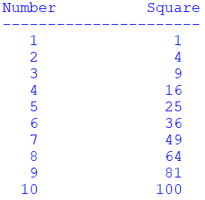
- Write a program that uses two variables num1 and num2, and uses a nested loop to display the following output of 3 rows with 5 columns. Consider where the line feed should be located in the loop structures.
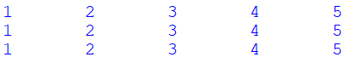
- Write a program that prompts for a word from the user, and then displays each character in the word separated by a tab. As an example, if the word “Python” were entered:
- Write a program that prompts for a word from the user, and then displays every other letter with a space between them. As an example, if the user entered “Exceptional”:
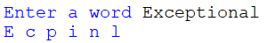
- Modify the program from chapter4 that prompts the user for a temperature and then “F or f” or “C or c” if it is a Fahrenheit or Celsius temperature to convert. Display both of the temperatures or “That the letter is invalid” if an incorrect letter was entered. Allow the user to convert another temperature without restarting the program. The equations for the conversions are:
C = (F – 32) / 1.8 F = (C * 1.8) + 32
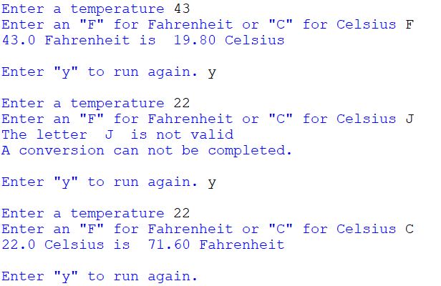
- Modify the Wind Chill program from chapter 4 to allow the user to compute multiple wind chill factors without restarting the program. Validate the input for temperatures less than or equal to 50 degrees and wind speeds > 3.0 mph. Display an error message and prompt again when invalid data is entered.
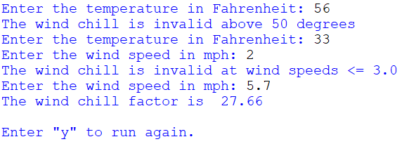
- Write a program that requests a cable length (must be positive) from the user and a cable thickness (must be between 0.1 and 2.5). Validate the input and keep requesting until valid input is received. Write a loop that will simulate the cable stretching as one pound of tension is added for each iteration of the loop. The cable will stretch its thickness times 0.28 feet for each pound of tension applied. The cable will break when it is 112% of its original length. Output the length and tension on the cable for each pound applied and announce when the cable has broken. Sample output:
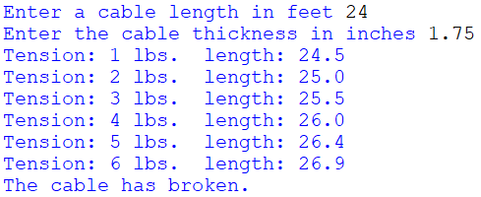
Chapter 5 Programming Challenge
Drainage Canal
The canal has a natural flow rate of 40 ft³ /s at 3.3 feet. Rainfall increases the water level of the canal and a flood gate must be opened to remove the excess water.
Prompt the user for the water level in feet (must be > 3.3) and the number of feet to open the flood gate (must be >= 1), and compute the time to lower the level to 3.3 feet while displaying the minutes passed, and the current level of the canal to two (2) decimal places.
The program will simulate the discharge of water through the flood gate at a rate of 0.03 feet of water per minute for each foot that the food gate is open. This will continue until the water level in the canal has reached 3.3 feet.
The program will validate the input only allowing a water level > 3.3 and a gate opening >= 1, and then start a loop to simulate draining the canal and display the minutes passed and current water level each time the loop executes. The program will end and announce when the canal has reached the natural level of 3.3 feet.
Note the output alignment in the sample.
